The Giving Tree
The giving tree is a large natured based structure that collects energy from the sun and powers itself as well as the pier, and the largest structure would act as a lighthouse. It has large Solar panels on the top resembling trees, the inside of the structures will have desalinization tech that cleans the water from the sea and sends it to the drinking fountains in the pier. The Giving tree was influenced by Antoni Gaudi’s La Sagrada familia, and the lone cypress tree in Pebble beach. It resembles a tree and like a tree it collects energy from the sun, and water from its surroundings in order so give us power and clean water. The techs used in this structure would be Solar panels, and desalinization tanks. 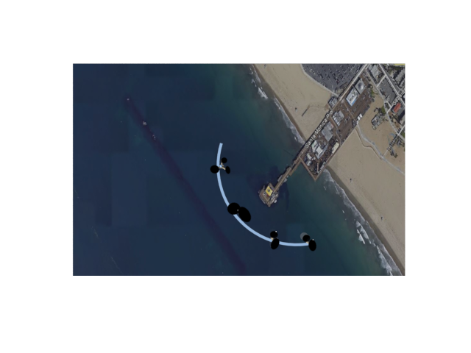
The regular structures will be approximately 170 feet tall, and the largest of the structures will be 250 feet tall, the solar panels will be 50-60ft radius and will be able to adjust according to the position of the sun.

Green energy
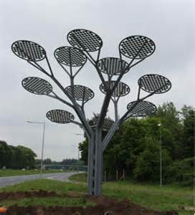

The giving tree will use 2 types of technologies; solar energy to produce power in order to keep itself and the pier running. The second one is water desalinization, it will clean the sea water store it within the large structures and convert it to drinkable water for the pier.

The solar panels above the structures will be large in size and will be able to produce between a few hundred Kilowatts per hour per structure depending on time of day and weather conditions.
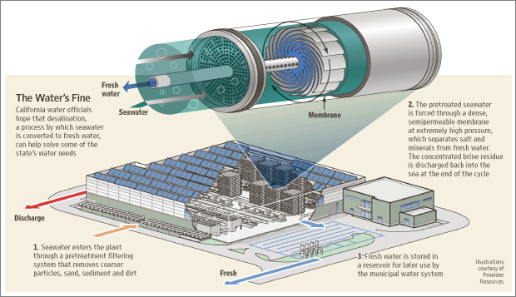
Like the image above, the Water desalinization will be located within the large structures; it will depend on the energy generated by the solar panels in order to function. Due to the size of the structures it will be able to generate
