Weightless Balloons

An art installation that generates clean electricity

The horizon has a strong presence on the site; sea and sky nearly touching, trying to merge in the distance. Two endless parallel surfaces attracted to each other, unsuccessfully willing to contact.

Time Exposed: #367 Black Sea, Inebolu, 1991, by Hiroshi Sugimoto. Source: https://paddle8.com/work/hiroshi-sugimoto/25933-time-exposed-367-black-sea-inebolu

The pier with its thousand legs is walking inside the ocean, attempting to reach that imaginary and impossible contact point between air and water. The amusement park colonises the platform and, in the middle of the attractions, the balloon seller offers us the fantasy of weightless deliverance; the dream of floating above our everyday struggle.

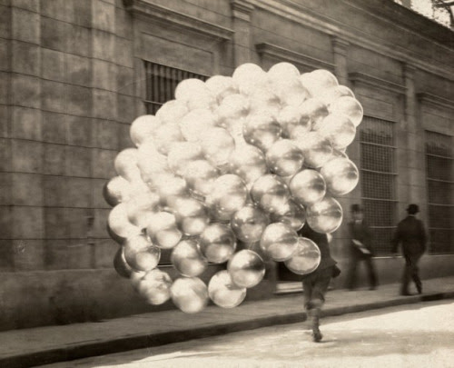
Source: http://neoterist.tumblr.com/post/59498042929/balloon-seller-in-buenos-aires-1921-source?utm_campaign=SharedPost&utm_medium=Email&utm_source=TumblriOS

The art installation wants to be a set of ethereal bubbles emerging from the sea, floating on the surface, moving to the rhythm of the waves. They are gas spheres protected by a metallic skeleton, like water molecules aspiring to abandon its liquid state to evaporate and blend with the air. This hope of freedom is fulfilled by the wind, which releases the balloons and makes them fly at its will.

The energy released derives from the fight of the bubbles against the tidal forces and the dance with the wind.

The permanent transformation of the structures’ arrangement conveys the impermanence of life. The perception of constant change, that characterises the universe and our lives, is reinforced by the shimmering effect of the sunlight reflected onto the balloons’ skin and bones. The low tide would also allow the balloons to hide behind the breakwater. The result is a dynamic, engaging art installation that captures our attention with repetitive but unpredictable calmed movements, like the waves do. This will bring us into a state of quietness, concentration and meditation that can free our minds from everyday troubles, setting us as free as the bubbles we are contemplating, bringing the illusion of letting us avoid gravity and merge into the sky.

Energy Production
Waves and wind are two unlimited and carbon-free sources of energy, that are disposable most of the time and all year round in California. Therefore, we thought that they would be the most convenient for our environmental friendly proposal. PV panels were not considered because of the high levels of CO₂ released on their production process and during their lifetime.

As an energy producer device, the artwork can function in two different modes. After analysing the weather conditions, a computer determines if the electric power than could be generated from the tidal kinetics would be greater that the power that could be produced by the wind, switching from one mode to the other, if adequate.

Tidal Kinetics

The balloon will be filled with an inert gas, lighter than air, as for example helium or hydrogen. The gas will keep the structure floating on or over the water surface. Balloons will be fabricated with an inflatable, double EFTE plastic layer, which is transparent but very resistant.

The bubbles’ structure is attached to a coiling gear which automatically adjusts the length of the cable to the tidal conditions, and allows to alternate between the Buoy and the Ari Generator modes. The coilers work with a mechanism very similar to the sailboats’ coilers. They are able to operate in constant contact with the water, and bear strong loads.

The cables keep the balloons anchored to the seabed. Besides this, they also have an internal conductor the drives the electric power to land. The cables would have a spool that coils the cable to adjust its length, adapting it to the tidal or aerial condition of the generator.

The conversion efficiency of this mode would be up to 80%.

Airborne Wind Turbines
If the computer detects good wind conditions, the structures will rise in the air and spin around their axis to produce electric power.

The gas lighter than air inside the balloons will help the structure to rise in the air.

Besides providing the necessary structural stability, the profiles would be blade-shaped oriented to obtain the best performance of the winds. The structure would be fiberglass; lightweight yet very durable, standing the harsh sea conditions.

A dynamo would generate electric power through the axial rotation of the balloon. Dynamos would allow to profit up to 40% of the wind power.

Environmental Impact Assessment
The artwork proposed has a low environmental impact. The balloons contact the surroundings only with the foundations, which will be scattered concrete blocks set on the seabed. These foundations will soon be covered by seaweed.

The slow speed of movement will not disturb local fauna. Birds will be aware of their presence and will easily avoid them. The impact over the sea creatures will be minimum as well, because the structures will float on the sea surface, and they can swim freely among the supports.

Having smooth curved surfaces and widely separated, blade-shaped frames will prevent wind from create acoustic pollution. The inflatable spheres are made of EFTE plastic, which is translucent, and the slender fiberglass structure will allow the artwork integrate into the landscape, with almost not visual impact from the distance.

The different balloons will be placed at enough distance to avoid collisions among them. As the site will be not accessible for the public, the repercussions on the environment regarding waste and noise, will be minimum.

