Santa Monica pier has always been known to tourists; to add one more visible sculpture into the existing pier that reflects ‘Californian lifestyle’ is what we are proposing. We call this sculptural project ‘California Poppy Dancers’ in hope to improve conditions of the World we are given one project at a time. California Poppy Dancers creates art form from energy-saving materials that are already in the market without having to reinvent new ones.
California Poppy Dancers serves a triple purpose: sculpture, electricity generator and water reclaimed facility. There are two main parts of the project:
- Three dancing ladies sculpture
- Outdoor gym pier
The three women sculpture
Form of three ladies comes from California high spirit in vibrant colors. All three appear as if they are constantly dancing on the ocean surface at 40-meter-tall each to be visible from the local road for people to selfie with. Their lowest hem is positioned at least 2 meter above ocean surface to avoid the raising water level, due to polar ice cap melting. The three poppy ladies festively spin around match the fun energy giving by the existing Merry-go-round. Their upper body spin(dance) into the wind stream also generates electricity via vertical windmill [Piezo Technology*¹].
California Poppy

These three Poppy Dancers represent a community, working together to harvest energy for Santa Monica. Dance moves express ‘Californian spirit’ which is fun, beautiful and responsible. Each woman wears Organic Photovoltaic skirt [Solarmer*² OPV] in 3 pedals that face South and Southwest. The other two pedals made of Solar absorption fabric [Solopower-SoloPanel SP3*³]. All pedals are backed up with Ethylene tetrafluoroethylene (ETFE) sheet for strength.
Impression of dancing dolls comes from within treasure boxes to inspire children to realize that every object can be repurpose in useful ways, like how these dolls can generate electricity for a big city.
Since California coasts locate on the Pacific Ring of Fire, we separate the three ladies by 200 meters to allow them to sway during seismic activity and not colliding to each other. Moreover, each pier column and each lady’s support has a Lead Rubber Bearing [Mageba – Lasto LRB*⁴] to isolate vibration during seismic activity. Bases of the three poppy ladies can be securely placed on the breakwater by adding structural reinforced concrete to existing mass to fix the erosion. We can also breathe a life into this break water by growing reef to invite wild life on the concrete’s outer shell, by planting tiny pieces of reef into small pieces of concrete.
We can harvest tidal power using buoys [Columbia Power Technologies, Inc*⁵] to generate electricity in the area in front of the three poppy ladies. Each lady then restores the energy harvested to pass onto control room in the pier. And when proven that such product generates satisfying amount of electricity for the city, they can be added into the sea space between the existing pier and new pier for closer speculation for visitors.
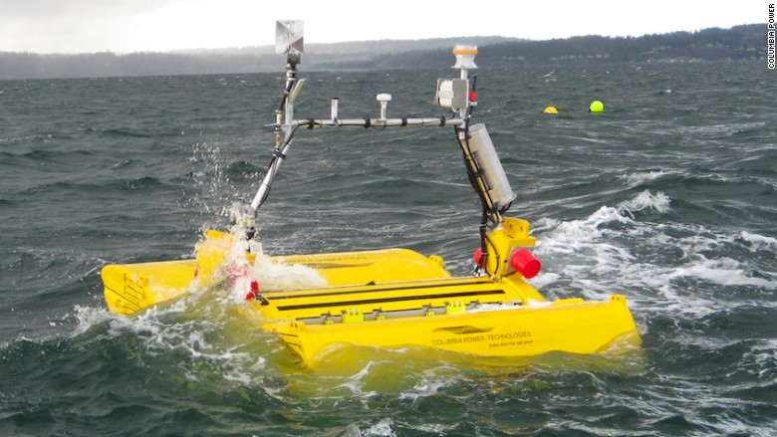

Product of Columbia Power Technologies, Inc

(http://money.cnn.com/2016/04/19/technology/waves-columbia-power/index.html)

The pier
We relocate the shipping docks farther into the ocean so that ships can dock on South and East of the new pier and smaller civilian boats can dock at stair bay, closer to more shallow area and in closer proximity of the existing pier. People can also use these stairs as recreation areas. To avoid both erosion and collision to damage the concrete, reclaimed truck tires will be placed at outer shell of the pier where possible.
The new pier extends to the spot in close proximity of their skirt hems for being a tourist attraction and control room. Physically, this pier also acts as though an enormous flask, collecting storm water from the surface and from existing pier. The pier employs 3 methods to treat water runoff:
- Filtered water will be used as cleaning, flushing and gardening water.
- Solar Powered Clean Water [Solarmer*^{2,} Pure Aqua Inc.*⁶] will be used to purify the water runoff for consumption.
- Sea water that flood the pier surface during high tide can go through reverse osmosis process [Hall’s Culligan*⁷], condensed and turned into potent water. We place this facility under deck so that heating from boilers will not affect microclimate.
Decking surface has 3 methods to collect solar energy:
- Walkable Photovoltaic flooring [Onyx Solar*⁹]
- Walkway with Photovoltaic roofing for people in rainy or foggy days. Nowadays, we can order Photovoltaic easily from many manufacturers, although local businesses are recommended.
- 120 human-powered electricity generated bicycles [the Green Microgym *⁸] - generating electricity for people who may be interested in biking to for their city. Each bike shows how much energy generated on a screen between the handles; after biking one can download the result into their personal exercise device.
Visitors can sight-seeing on the observation deck with coin binoculars, or go below deck to observe the control room directly below. The control room gathers electricity produced from the three Poppy Dancers, walkway roof, buoys, smart decking surface and the human-powered bicycles to distribute electricity to wherever the city wants.
To minimize damage done to the environment, we do not need fancy state-of-the-art construction techniques for energy-saving so that we save on operating costs, equipment, etc. California Poppy Dancers simply utilize solar panels and windmills to harvest renewable energy and shape them in form of sculpture for artistic use. We simply incorporate flexibility and movement into the structure/ sculpture via Lead Rubber Bearing to deal with lateral load during earthquake, making sure this Three California Poppy Ladies project is reliable for Santa Monica’s consumption. With all these, we are hoping to minimize carbon footprint and restore some ocean wild life for greener future.

Addendum

- Piezo Technology

PI Ceramic GmbH
Lindenstrasse
07589 Lederhose
Germany
Phone +49 36604 882-0
Fax +49 36604 882-4109
Email info@piceramic.com
www.piceramic.com

Solarmer

3445 Fletcher Ave, El Monte, CA, 91731

- Solopower
http://solopower.com/
6308 North Marine Drive
Portland, Oregon 97203

- Mageba
188 Hillsdale Avenue, San Jose, CA
Phone: 408-281-9700
Email: info@magebausa.com

- Columbia Power Technologies, Inc
http://columbiapwr.com/
4920A SW 3rd Street Corvallis, OR 97333
Email: (541) 368-5033
236 East High Street Charlottesville, VA 22902
Email: (434) 220-7590
Email: info@columbiapwr.com

- Pure Aqua Inc.
http://www.pureaqua.com/
Phone: (714) 432-9996
Email: sales@pureaqua.com

- Hall’s Culligan
http://culligancommercialwater.com/commercial-products/pre-treatment-solutions
info@culligancommercialwater.com

- The Green Microgym
http://www.thegreenmicrogym.com/the-story-of-the-upcycle-eco-charger/
Contact: Adam 503-933-2230
Email: adam@thegreenmicrogym.com

- Onyx Solar

http://www.onyxsolar.com/walkable-photovoltaic-roof.html
1123 Broadway, Suite 908
New York, NY 10010
Phone: (917) 261 4783
Email: usa@onyxsolar.com

Environmental Impact Statement
1/1
First and foremost, this project has to achieve two goals: aesthetic and energy conservation; California Poppy Dancers is proposed to doing so by mimicking Californian spirit into the sculpture while using readily available materials in the market to produce and store as much electricity can we can squeeze for city of Santa Monica.
A new concrete pier encroaching into the ocean may not initially present itself as the best environmental friendly project; however, this pier is cladded with solar collectors on the floor and walkway roof as well as embedded with water purifying equipment for the area. Functionally, she serves not only as ship and boat docking area but also recreational space for visitors to observe the three beautiful sculptures: California Poppy Dancers. This new pier adds a capability to welcome smaller vessel (as supposed to only large ship in the existing one) by reaching farther into the ocean, so that large ships can dock in deeper water, while small yachts can use shallower area. It gives another mean to approach this area of the city.
Socially, people can participate in this endeavor firsthand by cycling one of the stationed bicycles and one can receive a report on how much energy they contribute to city of Santa Monica. Visitors can observe the total energy produced from many methods such as using ocean wave, sunlight and kinetic energy in the control room under observation dock.
Visually, these three elegant lady sculptures can be seen from afar to dance in true Californian spirit. And even more true to ‘Californian’ intellectual form, these beautiful ladies also harvest kinetic and solar energy while dancing/ spinning with the strong wind provided by mother nature.
All in all, we hope to offset damages from erecting a new construction by using it as memorable generator for city of Santa Monica.

